AREDN Setup  
V2.1

Andreas Spiess, HB9BLA (hb9bla@gmail.com)  
  
13.11.2024

Content

Preparation 3

Yealink Phones 5

Flash the Phone 5

Phone Setup 6

Standard phone book 10

Backup phonebook (with full mesh address) 10

Flash Mikrotik devices 12

Preparations 12

Change PC to a fixed IP address 12

Flash rb.elf to target device 14

Flash AREDN Firmware 16

Configure AREDN 17

My recommended settings for the hap routers (for the moment) 18

Make your telephone visible to the network 19

Set up a tunnel to the AREDN network 20

Install the Phonebook 23

Principle of operation 23

Installation 24

Troubleshooting: 25

Is the phonebook downloaded? 25

Config file (only for experts) 25

Using a PBX in parallel 26

Attachments 27

Google Sheets replication 27

# Preparation

You can find all relevant files on GitHub (<https://github.com/dhamstack/AREDNstack> )

Press "code" and "Download ZIP". The file is quite big (>500M):

Ein Bild, das Text, Screenshot, Zahl, Schrift enthält.

Extract the ZIP file:

Ein Bild, das Text, Screenshot, Software, Computersymbol enthält.

Now you should have all needed files in your Downloads/AREDNstack-main/ folder:

Ein Bild, das Text, Screenshot, Zahl, Schrift enthält.

Here you find firmware for our typical phones to flash with "free" firmware (not connected to a provider).

Ein Bild, das Text, Screenshot, Schrift, Zahl enthält.

# Yealink Phones

## Flash the Phone

This is not always needed. Try first without this step and return if needed. Continue with “Phone Setup”.

1. Download and unzip tftpd64.464.zip (the "run", not the setup version) (<https://bitbucket.org/phjounin/tftpd64/downloads/> )
2. Disconnect your computer from Wi-Fi and Ethernet and set a fixed IP address (e.g., 192.168.0.4)
3. Start tftp64.exe
4. Click the browse button to locate the TFTP root directory   
   Ein Bild, das Text, Screenshot, Schrift, Zahl enthält.

   Automatisch generierte Beschreibung  
   You should be able to see the files your phone will request during flashing.
5. Select the local IP address from the "Server Interface" drop-down menu.  
   Ein Bild, das Text enthält.

   Automatisch generierte Beschreibung  
   If you do not find your fixed IP, something is wrong, and you must start over.
6. Connect the SIP phone to the PC with an Ethernet cable. Use the “Internet” socket on the telephone. Use the “Internet” socket on the telephone
7. Power the Yealink with the speaker button pressed until you see a selection(TFTP or USB) or the below screen. Press 1 for TFTP if presented.
8. Fill in the fields as shown. Make sure you use a free IP address for the telephone (e.g., 192.168.0.230 ):

IP Addr: 192.168.0.230

Netmask: 255.255.255.0  
Gateway: 192.168.0.1  
TFTP IP: 192.168.0.4

1. Hit enter (OK) and wait. The display on the phone shows “Start Updating…”. You should see in the tftp64 window on the PC that the phone fetches files from your computer.
2. As soon as all files have been read from the PC, the phone will automatically restart. However, this can take a few minutes. As soon as the phone displays a display again (e.g. “Obtaining IP address…” carry out the following step
3. Hold down the OK button until the message “Reset to factory setting?” appears. Confirm this message with the »OK« key. The message “Resetting to factory setting, please wait” appears, and then the welcome screen appears.
4. Remove power from the phone
5. The flashing of the SIP phone is now finished, and the phone is now ready for settings for the AREDN mesh.
6. Connect the phone to your hap router (port 2-4) and to power. After booting, go to the “About” menu on your phone to find the IP address.

Now, you are ready for the next step.

## Phone Setup

Attention: Does not work with T42 phones. The entries must be made manually (see Checks)

With the firmware for your phone, you also find a file with the extension .cfg.

Ein Bild, das Text, Schrift, Zahl, Reihe enthält.

Edit this file and replace XXXXXX with the phone number you want for your phone. You can change the language by placing the # in the right place.

Ein Bild, das Text, Screenshot, Zahl, Schrift enthält.

Replace the display.name if you want. Save it.

Go to a browser, type the IP address of your phone into the address, and login using admin/admin.

Ein Bild, das Text, Screenshot, Schrift, Zahl enthält.

Change your password if you want.

Now go to Settings🡪 Configuration.

Ein Bild, das Text, Screenshot, Software, Webseite enthält.



Go to "Import CFG configuration file and browse to the Txx.cfg file you edited before. Hit "Import" and wait till the phone rebooted.

### Checks

Has to be entered manually for T42

SIP Server and your phone numbers have to be correct  
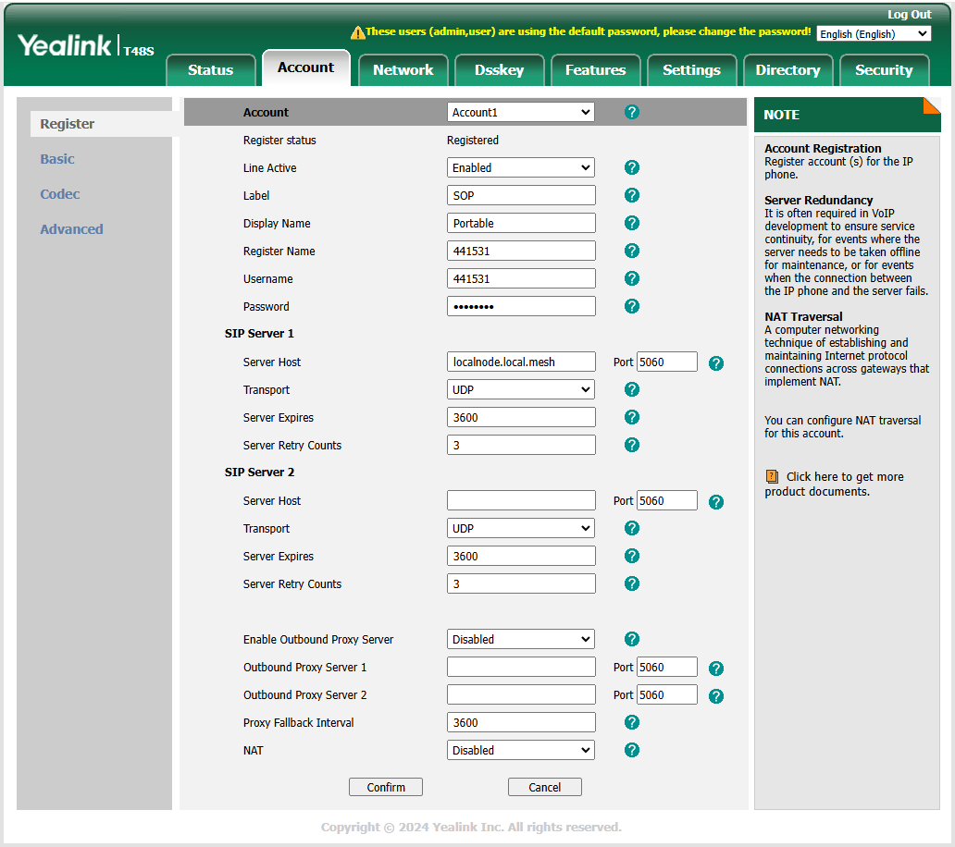

Check if your phone is enabled for IP telephony:  
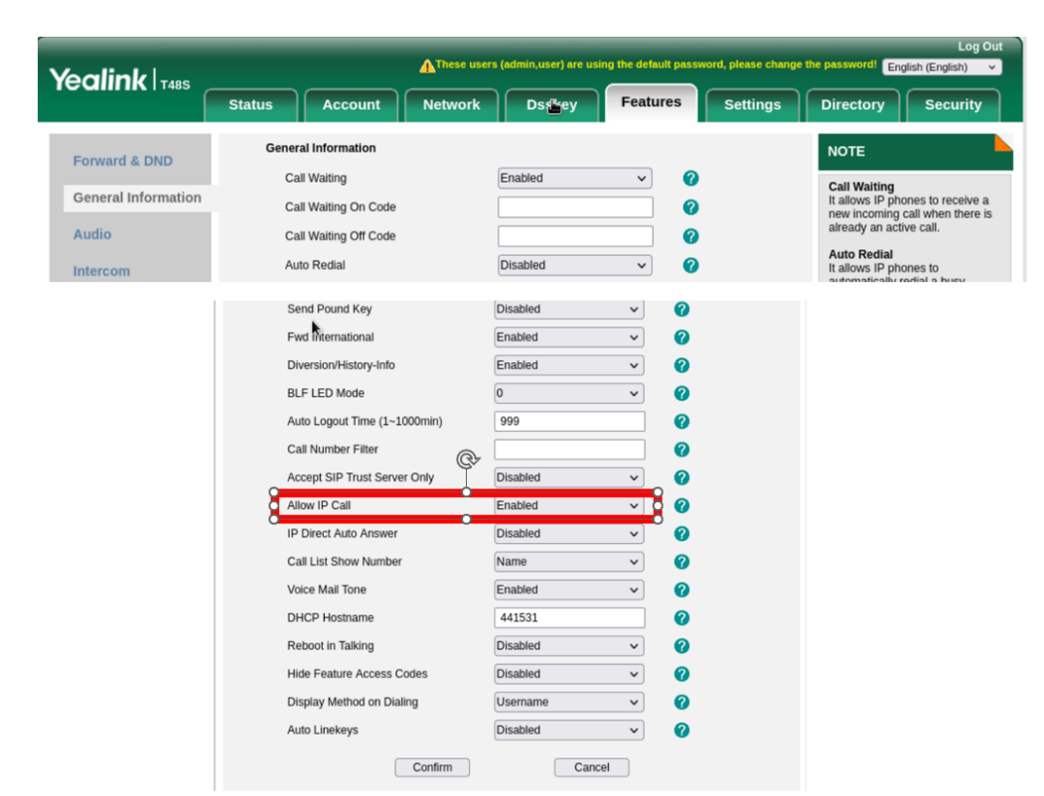

Go to Directory 🡪 Remote Phone Book and check if the remote phone book screen looks like that:  
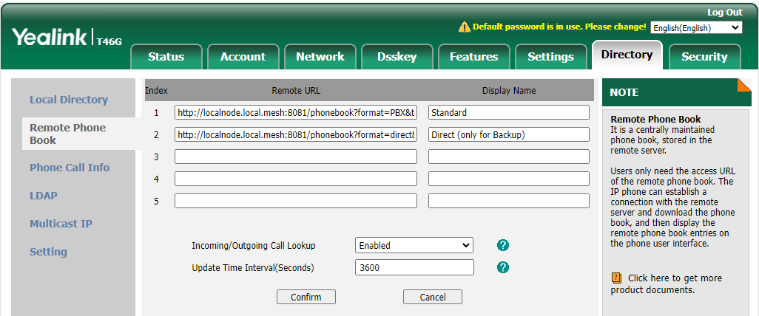

The two phonebooks for copy-paste (only if they are not here):

Standard phone book:

<http://localnode.local.mesh:8081/phonebook?format=PBX&target=generic&ia=true>

This file only stores the telephone number. The PBX knows this number anyway, and the SIP server in the phonebook program automatically creates the mesh address for direct calling.

Backup phonebook (with full mesh address):

If you want to store the full mesh address as a backup on your phone, you can add the second line. It is not needed.

<http://localnode.local.mesh:8081/phonebook?format=direct&target=generic&ia=true>

Go to Directory 🡪 Check or adjust fields. They should look like that:

Ein Bild, das Text, Screenshot, Software, Computersymbol enthält.
Press “Confirm”

Now, you should see a small phone in your phone's display that shows it is ready for the AREDN network. You should also see a "direct" and "PBX" folder if you press the "Directory" button on your phone.

If your Mikrotik router already works with AREDN, you can skip the next step and install the phonebook. If not, continue with the next chapter.

# Flash Mikrotik devices

## Preparations

The small Mikrotik hap ac-lite/ac3 box or square Access PointSXTsq (AP) will hereafter be referred to as "target devices." Green are the notes for the AP.

Download the “kernel” and “sysupdate” files for your device. Every letter in the name counts!

<https://downloads.arednmesh.org/afs/www/>

*Rename the kernel bin file file to rb.elf.*

Download the Tiny PXE Server ([*http://erwan.labalec.fr/tinypxeserver/pxesrv.zip*](http://erwan.labalec.fr/tinypxeserver/pxesrv.zip) ) and unpack it to a convenient directory.

Go to the Tiny PXE Server directory:

Ein Bild, das Text, Screenshot, Software, Multimedia-Software enthält.

And copy the rb.elf file from before to the «Files» folder of the PXE server (overwrite if necessary).

Connect your target device to a switch as shown below (connect the LAN cable to the “internet” port of the hap router):

Ein Bild, das Computer, Text, Elektronik, computer enthält.

Deactivate Wi-Fi on the PC and supply power to the dumb switch.

## Change PC to a fixed IP address

Type

ncpa.cpl

into Windows search

Ein Bild, das Text, Screenshot, Software, Multimedia-Software enthält.

Select "Ethernet"

Ein Bild, das Text enthält.

Select «Properties»:

Ein Bild, das Text, Screenshot, Software, Betriebssystem enthält.

Select IPV4:

Ein Bild, das Text enthält.

Input IP address 192.168.1.50:

Ein Bild, das Text enthält.

Press OK and Close

## Flash rb.elf to target device

Power the hap devices with a power supply, not with PoE.

Check if the ethernet cable is connected to **port 1** of the hap router (labeled with Internet), supply the router with power and wait until the top red LED is off and the green LED above with the number 1 flickers. Possibly Windows detects a new network. Then a larger blue window will appear on the right side of the screen, mentioning the new network. Confirm with OK. The whole thing takes about 3 minutes.

Do the same with the AP. Use the PoE injector (Y-cable) or a passive PoE switch for the power supply. The power supply unit of the router also works here (both are 24V).

Start Tiny PXE Server (double click on the pxesrv.exe file in the «pxesrv» directory). You might get this warning:

Ein Bild, das Text, Screenshot, Schrift enthält.
Ein Bild, das Text enthält.

Press «More info» and let the program run.

Now pull the power of the target device.

In the Tiny PXE Server window, select the IP address entered on the Ethernet adapter from the drop-down box (192.168.1.50). If this IP address cannot be selected, close the Tiny PXE Server and start it again. If it still doesn't work, check the IP4 adapter settings and start again.

Find and select rb.elf in the «Boot File» section. This file can be found in the «…\pxesrv\files» folder.

Uncheck «Filename if user class...». No additional settings are necessary.

Ein Bild, das Text, Screenshot, Zahl, Schrift enthält.

Now switch the Tiny PXE Server to «Online» in the upper right corner.

Then press the reset button in the target device with a pointed object (e.g., paper clip or toothpick) and then plug in the power cable to the target device. The USR LED will be on, flashing, and off (5 seconds each). Check the log window. Immediately after the bottom line says "Do ReadFile:rb.elf ………" release the reset button and switch the Tiny PXE Server to "Offline." This procedure takes about 20 seconds. The target device now boots with the AREDN firmware.

Don't keep the reset button pressed for too long, or you'll have to start over!

Keep the device powered. Otherwise, you have to start over!

If new messages (new requests) keep appearing in the window, you must use a different PC. Preferably one with little software installed.

After a few minutes, the process should be finished.

Plug the Ethernet cable into **port 2** on your router

With the AP, the Ethernet cable remains in the only socket. The rest is the same

## Flash AREDN Firmware

Now open a browser and enter 192.168.1.1. The picture should look something like this.

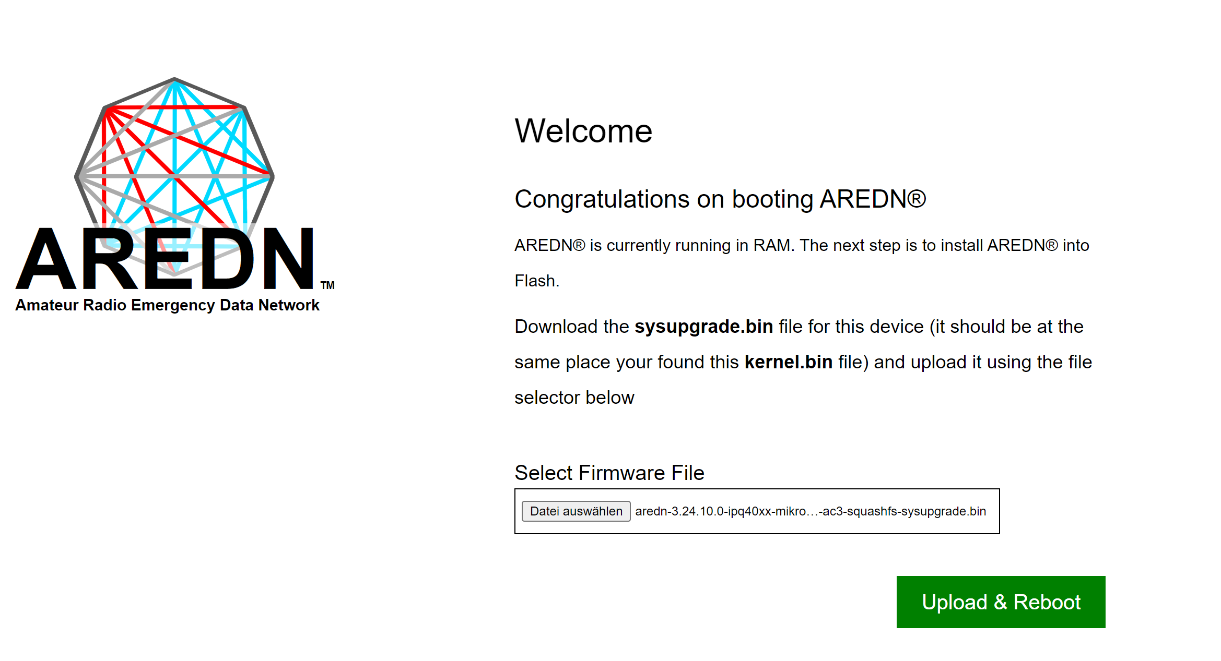

If not, back to start.

Now you can select the sysupgrade file for your router and hit “Upload”. Wait till you get an answer on <http://192.168.1.1>

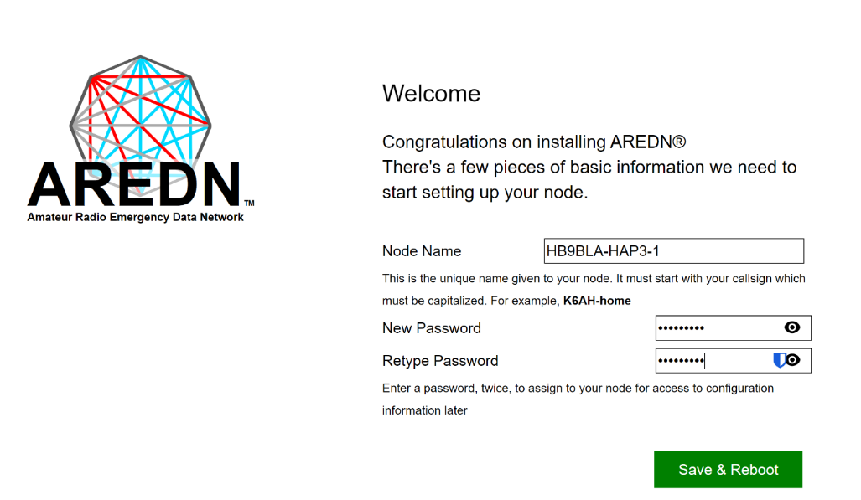

Enter the node name beginning with your call sign.

## Configure AREDN

Change your PC to DHCP. Open the browser and enter the following line

<http://localnode.local.mesh>

If there is no answer, the process is not yet complete. Try again and again. If you still can't connect after 15 minutes, go back and start over.

The new screen should show up where you can login to administer the node.

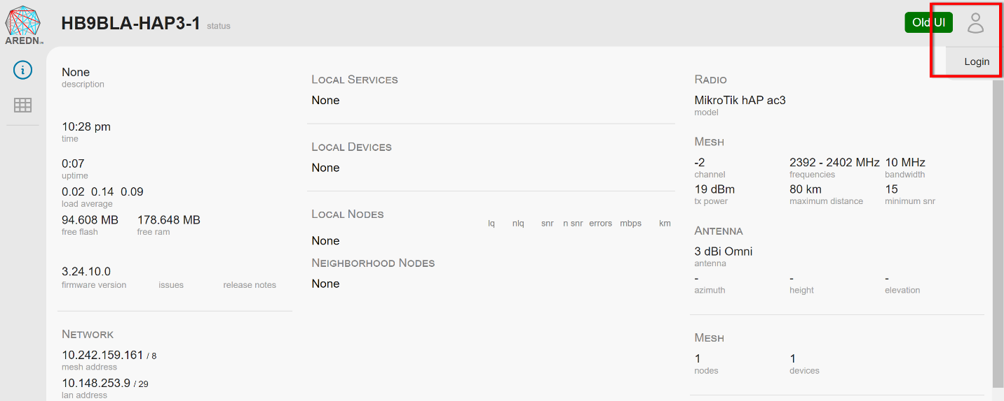

You see if you are in administration node when the UI looks like that:

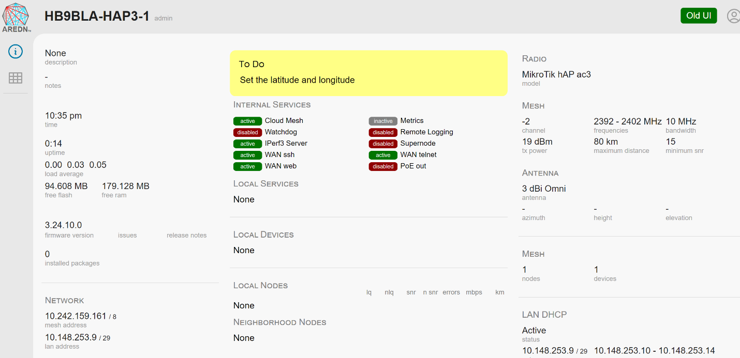

Changes are made everywhere on the screen when you see a grey shadow.

After changes, you have to commit them, and sometimes you are asked to reboot. There is no «reboot» button anymore.

## My recommended settings for the hap routers (for the moment)

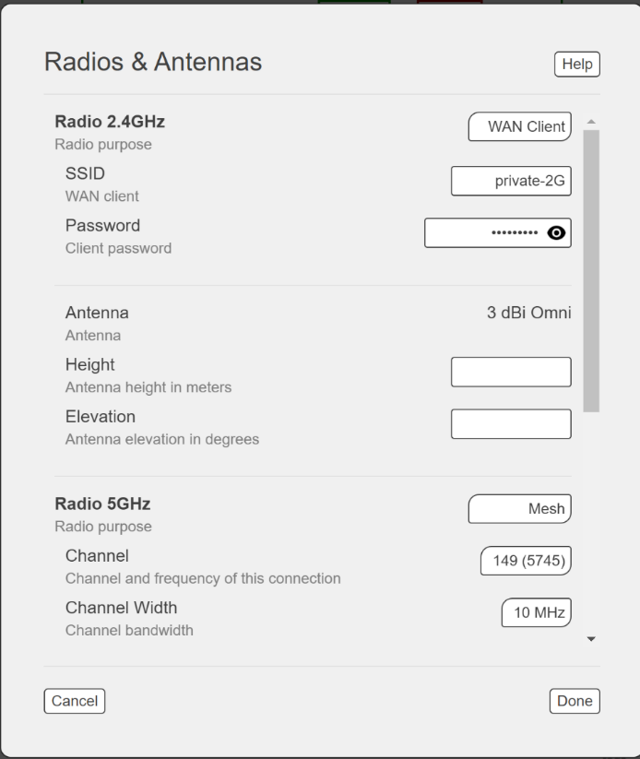

I connect my hap routers to Wi-Fi and create a mesh on 5GHz to test with other AREDN nodes. If you connect the hap via cable to the internet, you can switch the 2.4GHz radio to “off”.

## Make your telephone visible to the network

Telephones have to be visible to others The is why we have to reserve the address. This is done in the “LAN DHCP” area on the right. If you clock it you get to this screen:

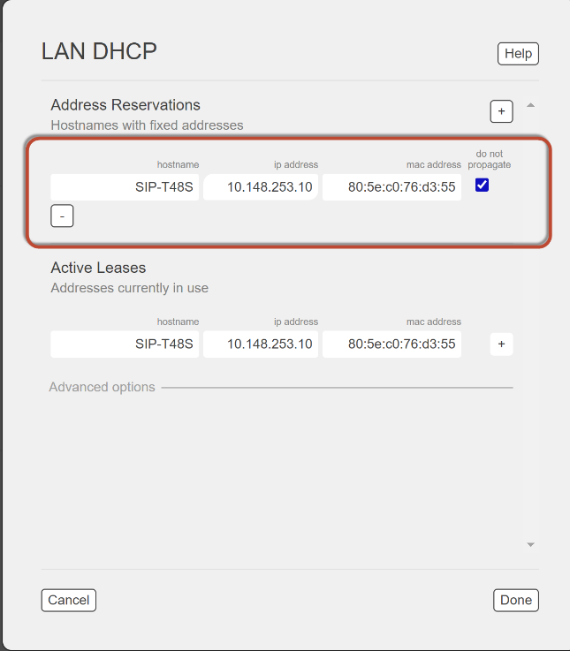

If you connect your Yealink phone, it should already be visible, and you just have to press the “+” button. Change its name to one of your unique phone numbers. You get the telephone numbers from HB9JAT, HB9BND, or HB9BLA. MAC address is found on the telephone under «information» (if needed).

Remove the tick at “do not propagate” to make it visible in the net.

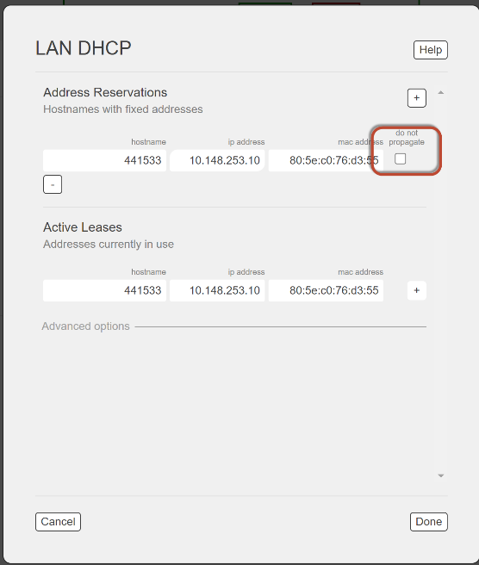

Now it is time to go to the network overview:

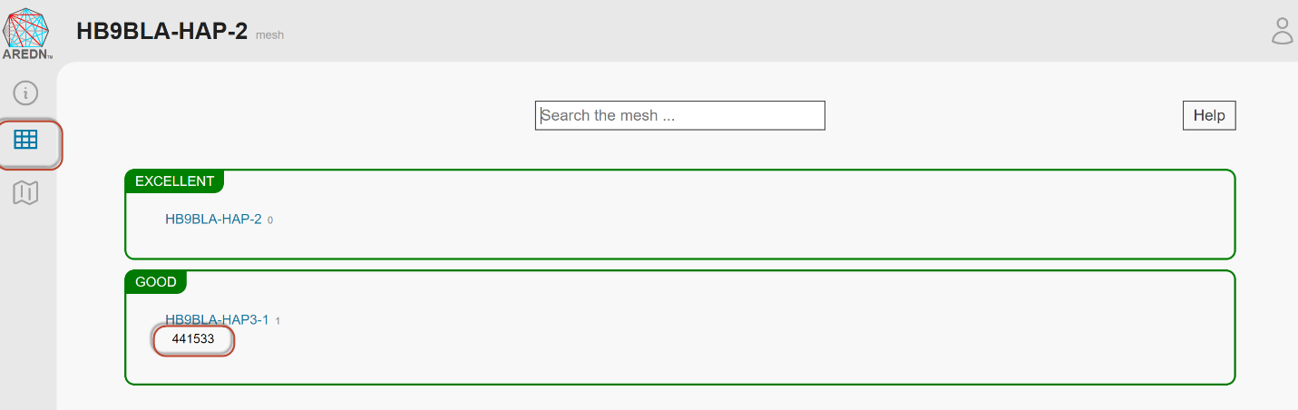

The phone should be visible under your router name.

## Set up a tunnel to the AREDN network

(only necessary if you connect via an Internet tunnel)

This chapter only applies to the hap routers.

Connect port 1 (Internet) to the Internet or connect via the network as shown before in my recommended settings.

From now on, you can access the router either if you connect a cable from your PC to ports 2-4 or via Wi-Fi.

The router should provide a network.

Ein Bild, das Text, Screenshot, Software, Betriebssystem enthält.

There are two different tunnels available. The owner of the tunnel server decides which one you have to use. Wireguard tunnels are the future.

The tunnel owner will send you a file with the needed info. For legacy tunnels, make sure your node name matches the one given to you by the owner. Otherwise it will not work.

Server: his server address

PwD: The password he assigned to your tunnel

Network: The address of your tunnel

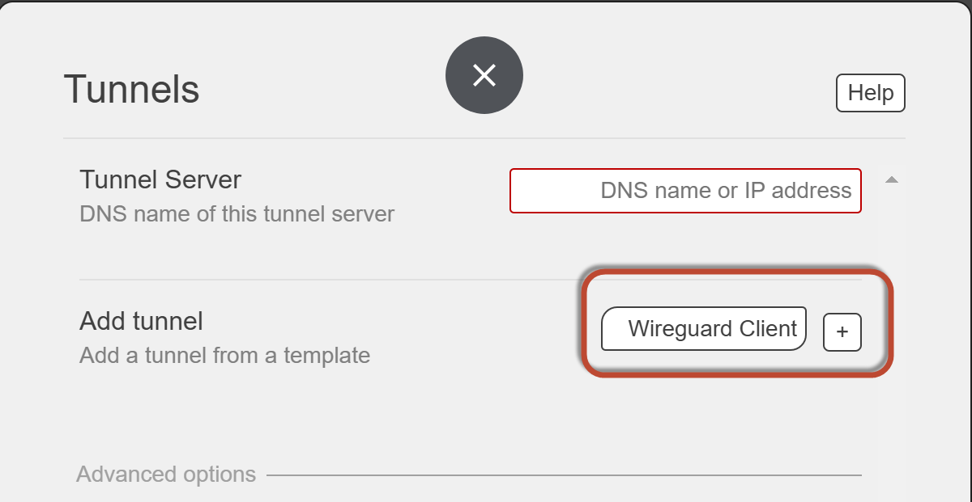

The field “Tunnel server” is left blank for clients. Chose Wireguard or Legacy client, press the plus sign, and fill in the information you got from the tunnel owner.

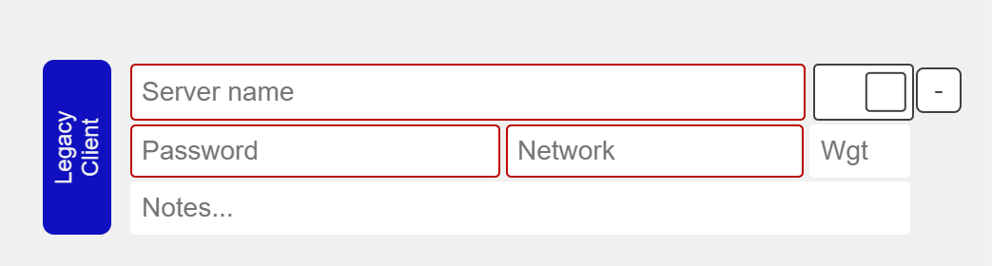

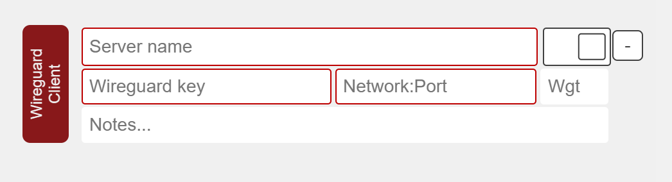

After you commit the changes, you should be connected (green) and your network should start to populate. You are now connected to the AREDN network. Go to «Node-Status» / «Mesh Status» and enjoy the success.

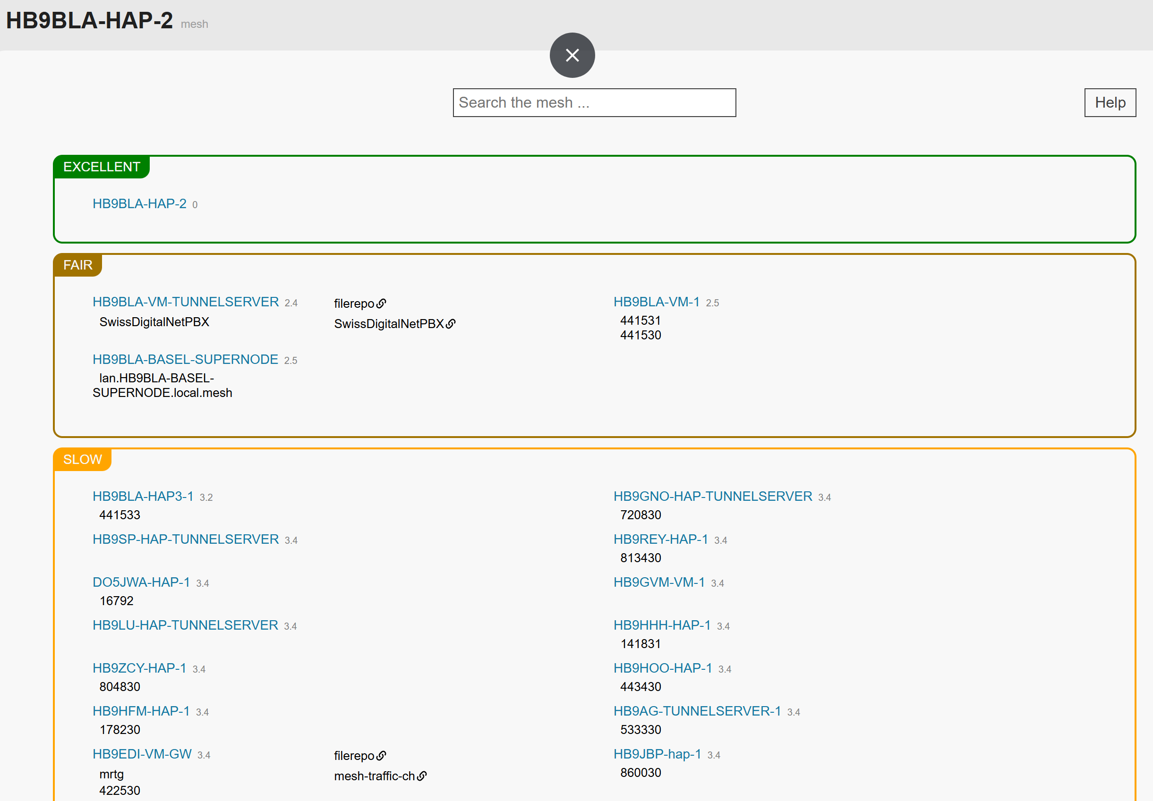

# Install the Phonebook

This project aims to create a common Global AREDN telephone network. Local telephone books are distributed to all participating AREDN phones connected to the SwissDigitalNetwork or, via Supernodes, worldwide. By storing the latest version on each router, we can ensure that, during an emergency, we have no single point of failure. Each phone can call all reachable phones without a (central) PBX.

## Principle of operation

You can skip this chapter and go to "Installation" if you are not interested in how the telephone book works.

AREDN is a mesh network, and we do not want to create a single point of failure. This is why the telephones get their phonebook files from the hap router they are connected to. So, a phone gets its phonebook as long as its router works.

We use direct calling instead of a PBX to avoid a single point of failure for communication, reduce the latency time, and reduce the overload of single mesh segments. The address used for this case is an FQDN like [178230@178230.local.mesh](mailto:178230@178230.local.mesh). If you want or need to operate a PBX, the address is just a phone number like 178230. In Switzerland, we use the city's zip code of the HAM plus a two-digit number in the range of 30-70. Lower numbers are reserved for official use.

The "Official" Swiss AREDN phonebook (SOP) is on Google: <https://docs.google.com/spreadsheets/d/1g33BHSXMC8T4Cmfz_Zq-XxtPP17dtEBexF2i4KKe_Mc/edit?usp=sharing>. You can create a comment to add or change something or notify one of the administrators to do it for you.

Other countries will have their own telephone book (one per international area code). The maximum length of a local phone number is 7.

xxx-yyyyyyy

xxx: 3-digit area code

yyyyyyy: 7-digit local number (in Switzerland, currently only 6 are used)

Examples:

A global number in Switzerland starts with 041 (e.g. 041441530). For your comfort, you only have to dial the short number (in Switzerland, 441530). The SIP server in the phonebook program automatically adds 041 (it is defined in the config file).

Other nations use their international area code. It must have three digits. So, the US has 001 and Lichtenstein 423.

Currently, we support Yealink telephones. Cisco phones should also work.

At power-up and every hour, the telephones used for AREDN automatically load phonebooks from the connected router. The file format used for that process is XML.

How is the information transferred from the Google Sheets to your hap router? The first step is to copy the .csv version of the sheet from Google to two web servers (one acts as a backup) in the AREDN mesh. If Google is down, we could still edit this .csv file manually. This transfer is done every hour. You find more info in attachement.

## Installation

Go to the releases page and open “Assets”:

<https://github.com/arednch/packages/releases>

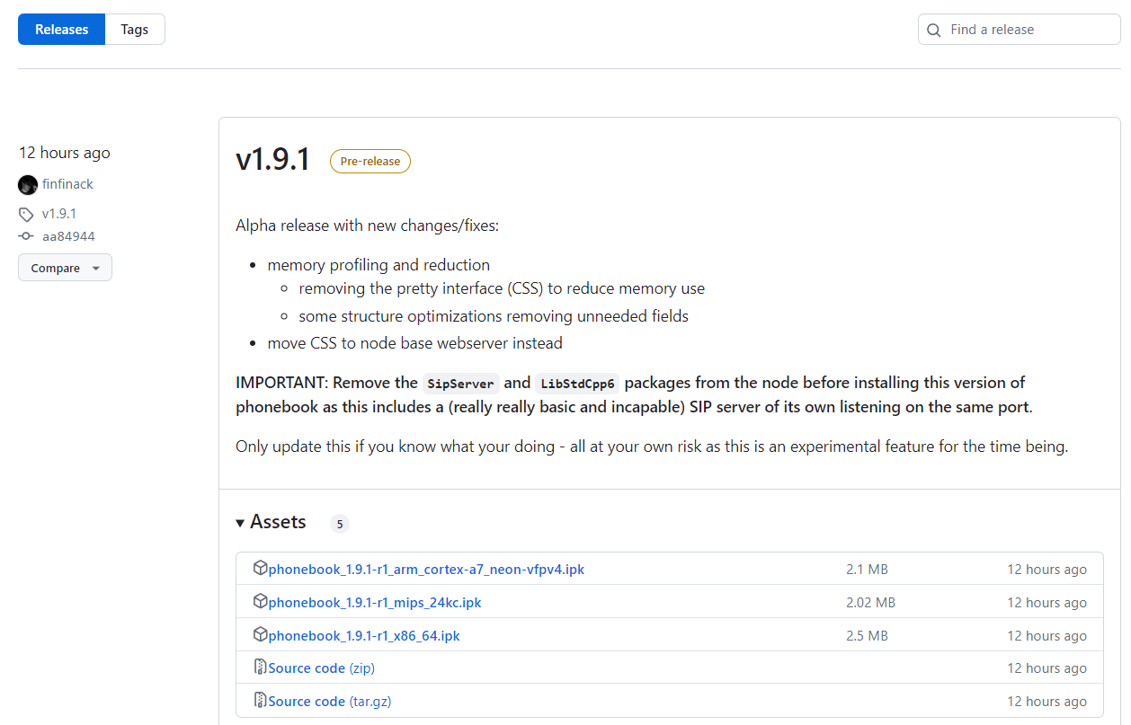

Download the respective ipk file (mips-24kc for the small hap lite and arm-cortex for the hap3). The ipk file includes the phonebook, the SIP server, and all libraries.

Go to “installed packages” on the left:

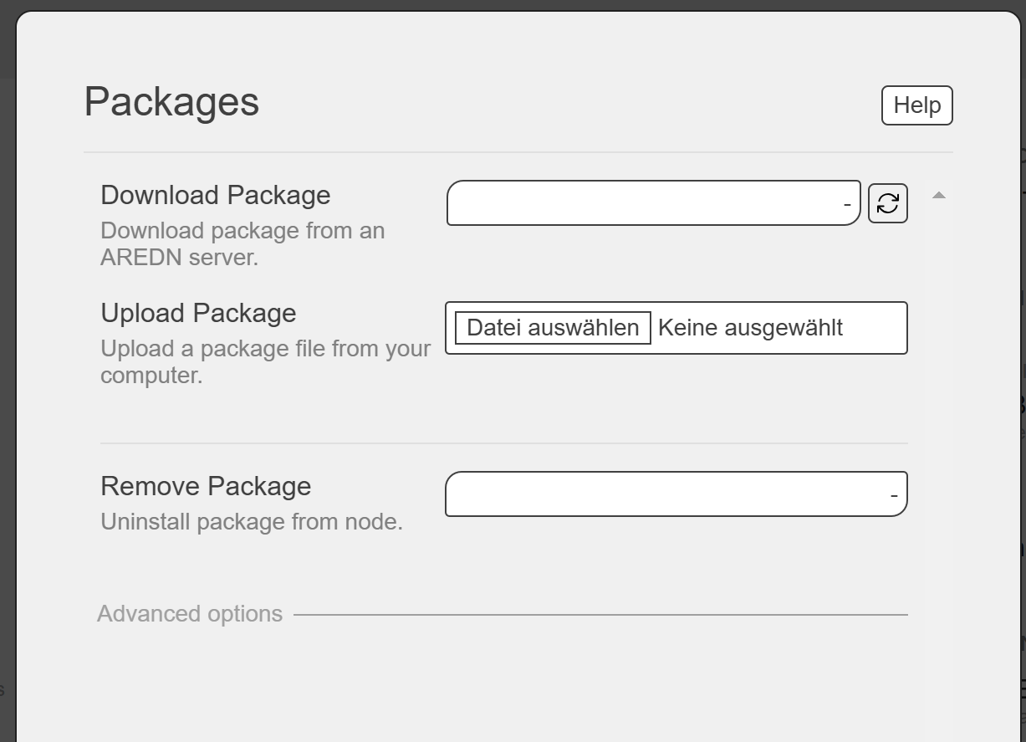

Chose the correct “phonebook” file and “upload it. This starts its installation.

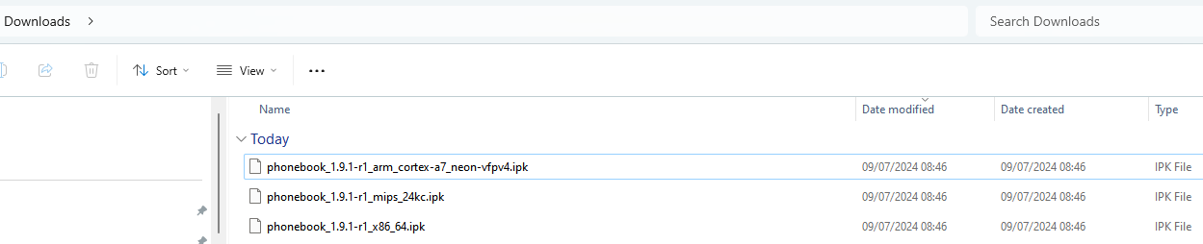

Now, you can connect your router to your AREDN network. After rebooting, the attached phone should connect to the SIP server, and you should be able to download the phonebook with all numbers.

## Troubleshooting:

### Is the phonebook downloaded?

[localnode.local.mesh:8081/phonebook?format=direct&target=generic&ia](http://localnode.local.mesh:8081/phonebook?format=direct&target=generic&ia)=true

should show you the actual phonebook

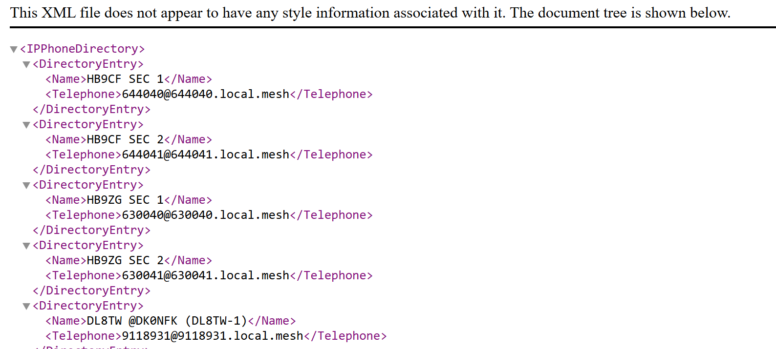

if not, type:

<localnode.local.mesh:8081/reload>

should load the actual telephone book from the AREDN server

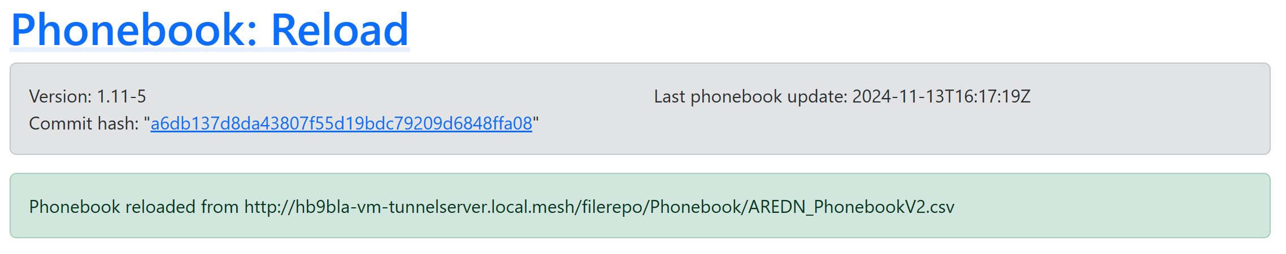

### Config file (only for experts)

You can influence the behaviour of your phonebook software by changing parameters with the command

vi /etc/phonebook.conf

Important are these two parts:

**formats: Comma separated list of formats to export.**

Default:

"formats": [

"direct",

"pbx"

],

- Supported: "pbx,direct,combined"

**targets: Comma-separated list of targets to export.**

Default:

"targets": [

"generic"

],

- Supported: generic,yealink,cisco,snom

## Using a PBX in parallel

If you want to use a PBX, you must add a second account with the respective information given to you by the PBX operator.

This is the end of the manual. The rest is for Administrators

------------------------------------------------------------------------------------------------------------------------------------------

# Attachments

These steps are executed on the server with the file repo.

## Google Sheets replication

Create a file on the “phonebook repo” server (in my case the tunnel server):

vi /etc/cron.hourly/load_phonebook_from_google

and insert:

#!/bin/sh

curl -L “https://docs.google.com/spreadsheets/d/e/2PACX-1vTZw1cwlV6pdFETvC-JnI0gPwKRwR0rBUc2XqX9V3LV1NfrB0zvhhWKmrYVS1eippbs91lMLfkeXj6-/pub?gid=0&single=true&output=csv” -o /www/filerepo/Phonebook/AREDN_PhonebookV2.csv

curl -L "https://docs.google.com/spreadsheets/d/e/2PACX-1vTZw1cwlV6pdFETvC-JnI0gPwKRwR0rBUc2XqX9V3LV1NfrB0zvhhWKmrYVS1eippbs91lMLfkeXj6-/pub?gid=0&single=true&output=csv" -o /www/filerepo/Phonebook/AREDN_Phonebook.csv

curl -L “https://docs.google.com/spreadsheets/d/e/2PACX-1vTZw1cwlV6pdFETvC-JnI0gPwKRwR0rBUc2XqX9V3LV1NfrB0zvhhWKmrYVS1eippbs91lMLfkeXj6-/pub?gid=208565882&single=true&output=csv

#!/bin/sh

curl -L "https://docs.google.com/spreadsheets/d/e/2PACX-1vTZw1cwlV6pdFETvC-JnI0gPwKRwR0rBUc2XqX9V3LV1NfrB0zvhhWKmrYVS1eippbs91lMLfkeXj6-/pub?gid=0&single=true&output=csv" -o /www/filerepo/Phonebook/AREDN_PhonebookV2.csv

curl -L "https://docs.google.com/spreadsheets/d/e/2PACX-1vTZw1cwlV6pdFETvC-JnI0gPwKRwR0rBUc2XqX9V3LV1NfrB0zvhhWKmrYVS1eippbs91lMLfkeXj6-/pub?gid=0&single=true&output=csv" -o /www/filerepo/Phonebook/AREDN_Phonebook.csv

Include the route to this phonebook repo (and eventually a backup server) to this file on all routers with the appropriate phonebook software:

vi /etc/phonebook.conf

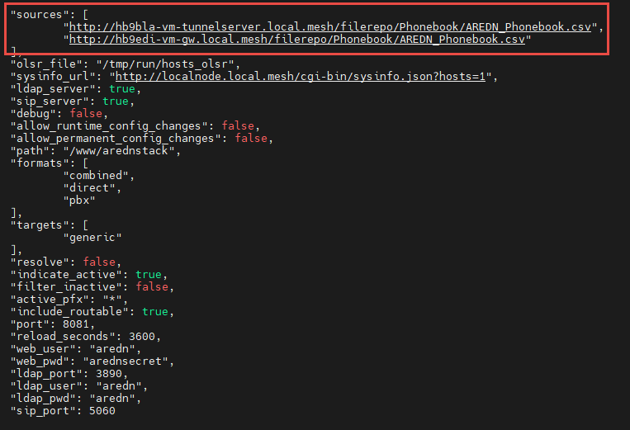

The second path is for backup.